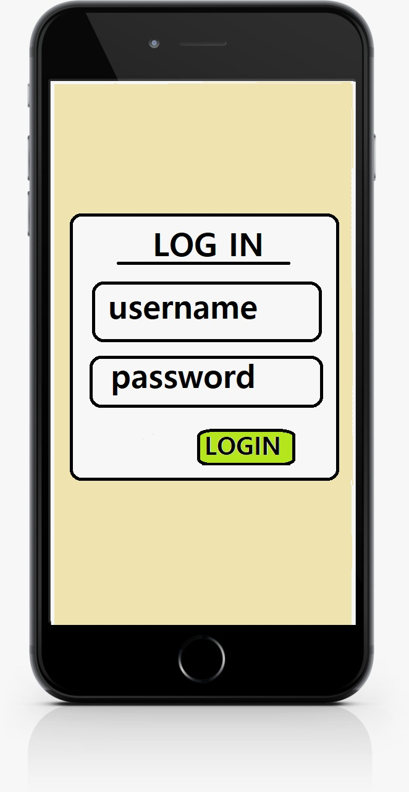**ADMIN PANEL**

**LOGIN PAGE:** Admin can login using this form to admin panel.

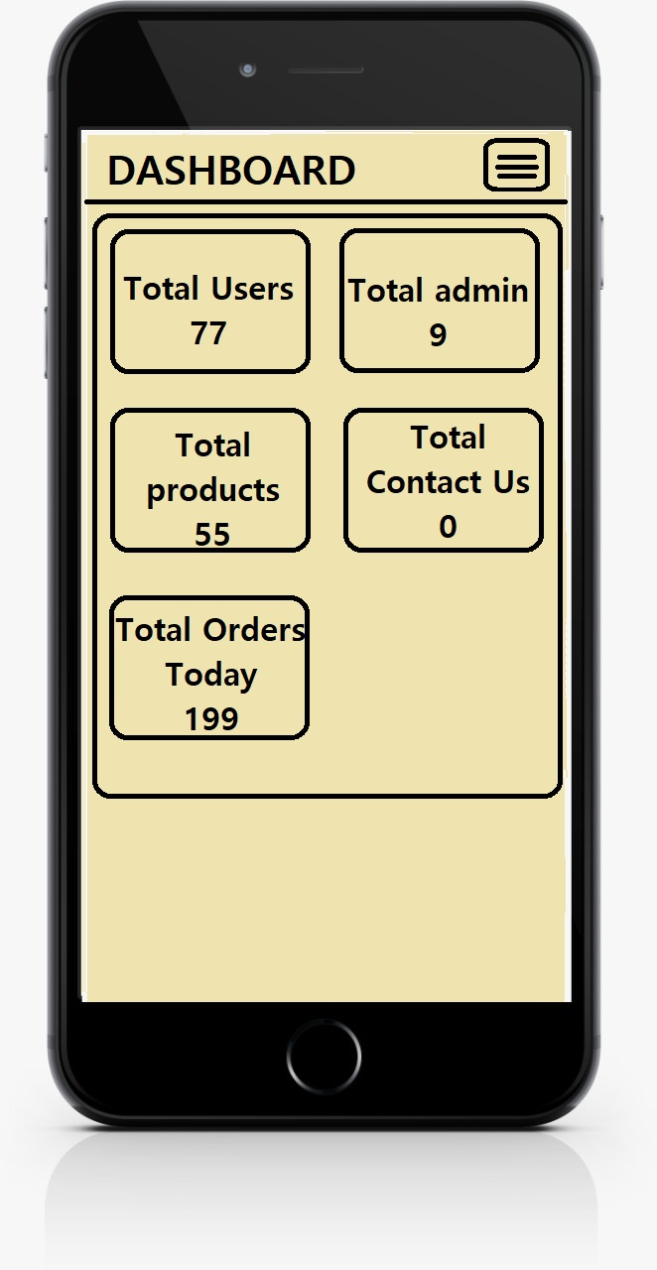

**DASHBOARD PAGE:** This page shows the overview about all the content in the database.

Such as number of users, admin, products, contacts and orders.

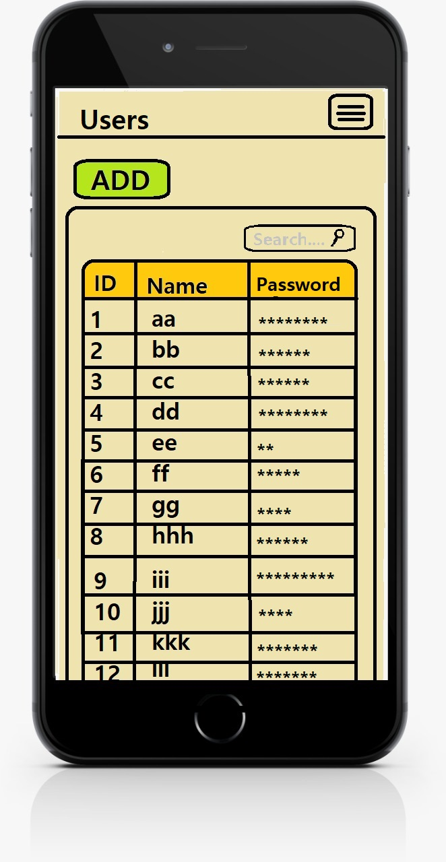

**USERS PAGE:** This page shows the users details and also it allows to add new one and modify existing one.

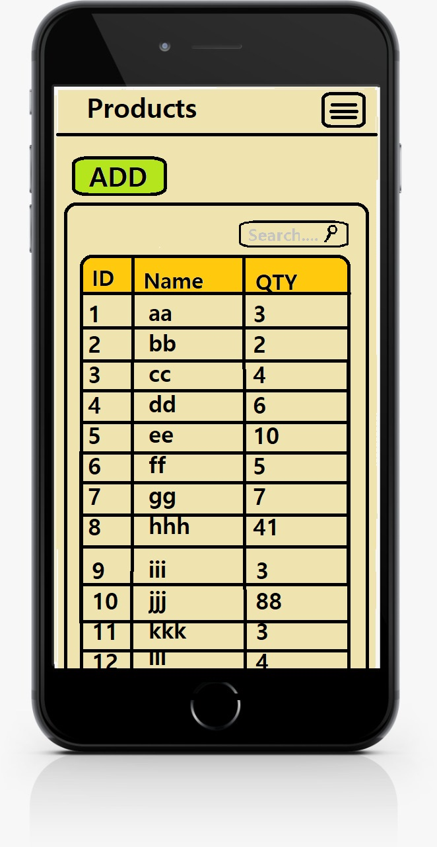

**PRODUCTS PAGE:** This page shows the product details and also it allows to add new one and modify existing one.

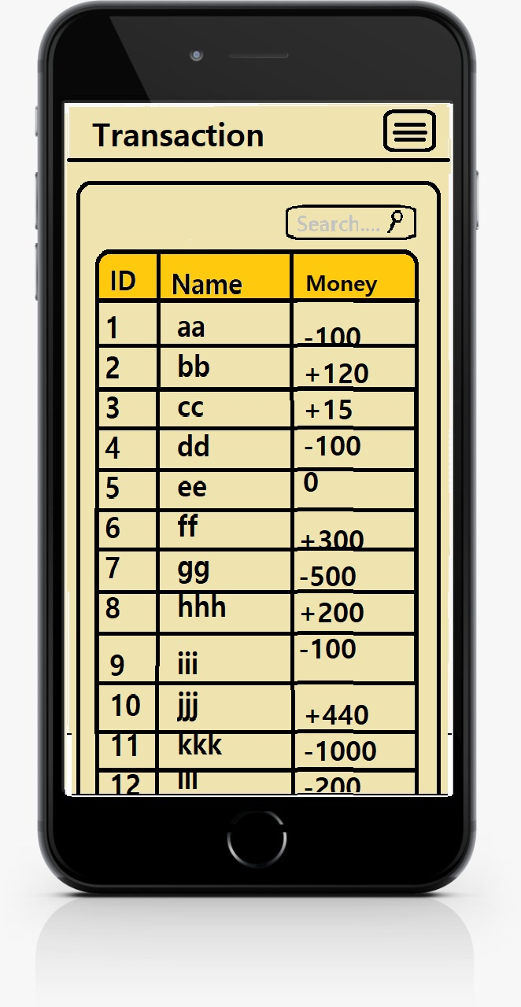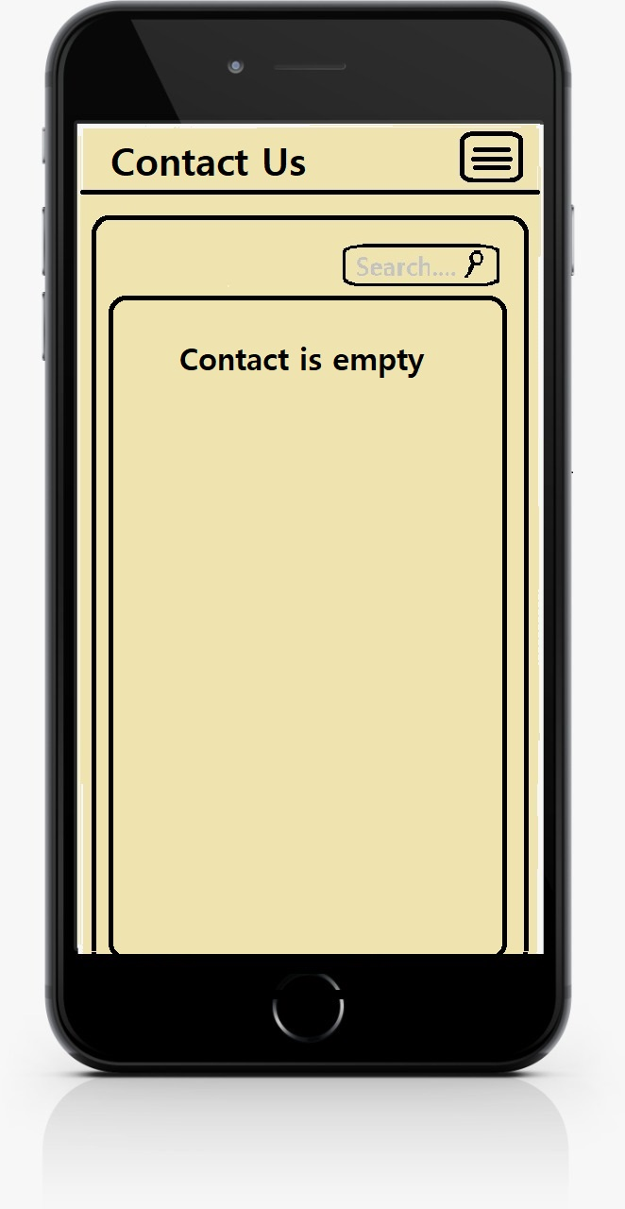

**TRANSACTION PAGE:** This page shows the list of transactions that has been done by the users.

**CONTACT US PAGE:** This page shows the list of contact us form filled details.